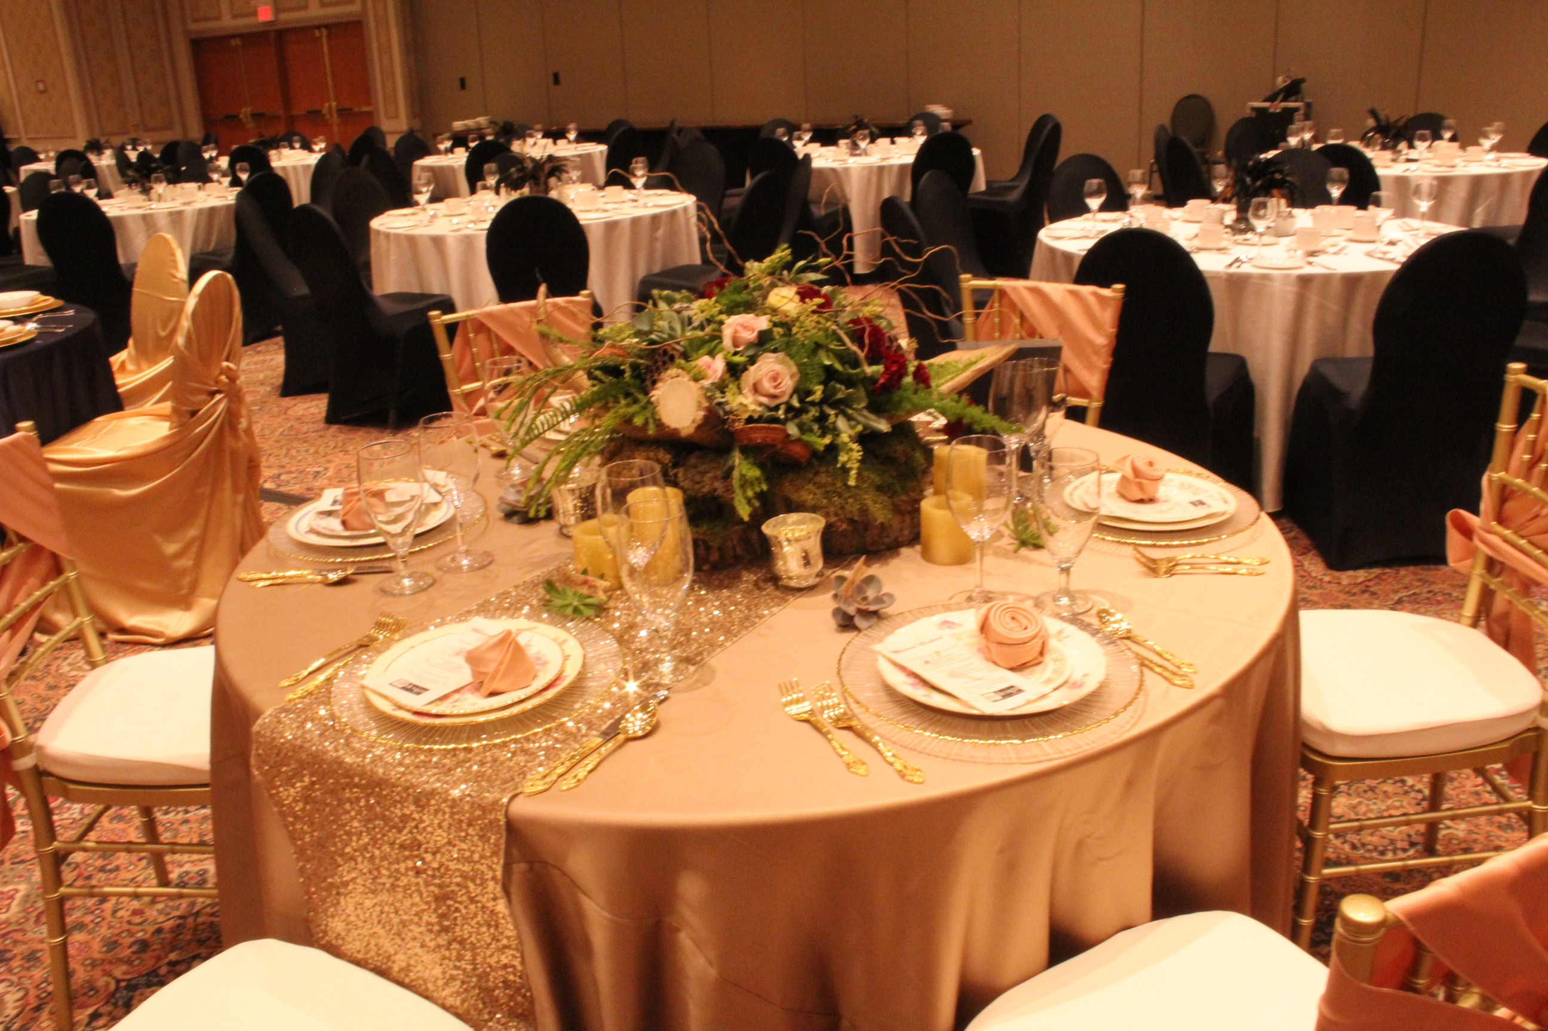  - March 6, 2018  CRA Ontario Awards Banquet  !!Attention Rental Operators!!  We challenge you to come up their most impressive tabletop design and impress your peers at our CRA Ontario Awards Banquet  Company Name:  Contact Name:  Contact Email:  5’ Round table and 8 banquet chairs will be provided by the hotel. Rental store is responsible for all table linen, chair covers, napkins and all decorations for one 5’ round table  *Tables will be anonymous until all ballots have been tallied*  Ballots will be available at the banquet for members to select a winning designer at the event.  Sign Up Now! | 2018 CRA Ontario Banquet Awards Tabletop Design Challenge  ____  $1000 prize donated by National Event Supply & feature in Canadian Rental Service Magazine  ____  Compete against your fellow rental operators for the title of “Most Creative Tabletop Design”  ____  to enter Forward Form to:  Mike Maltby  Awards Banquet Committee Chair  mike@ingersollrentall.ca  Fax: 519-485-6283

